Documentation

Assignment 1 – Web application Development

Shivneel Achari, 1463570

2018

# Preface

URL: <http://dochyper.unitec.ac.nz/achars05/asp_assignment>

Dochyper Folder: asp_assignment

Admin Login: [admin@email.c](mailto:admin@site.co)om / P@ssw0rd

Customer Login: [jstarton12@gmail.com](mailto:jstarton12@gmail.com) / P@ssw0rd

Type of Website: [Simple] Online Purchase Order System – Quality souvenirs.

Notes:

I have tried to setup dochyper for this assignment, but I wasn’t able to get it working.

This application (tries to) follows the ContosoUniversity Tutorial covered during classes.

Contents

Business Specifications 3

Business Rules 3

User Interface Design 6

Sitemap 6

Wireframe 7

Database Design 11

Tables 11

ERD 11

System Design Rationale 12

Techniques 12

Client-side 12

Server-side 12

Test Plan 13

# Business Specifications

## Business Rules

The application has two users; Customer and Administrator.

1. Customer

Customer can be differentiated into Guest (unregistered) and Member (registered). The following specifications are for both unless specified.

* 1. Home page, Product page, About page and Contact page.

There is a logo of the website which takes them to the home page.

Both guests and logged in customers can view these pages. They can navigate to the corresponding category by clicking on the category on home page.

They can view all the items on product page. Additionally, these products can be viewed by one category at a time by choosing one of category buttons in the same page. Each page displays products, if there are remaining entries then the rest will be displayed on the “Next” page.

* 1. Add Item to Shopping Cart

Both guests and logged in customers can add any available product to their shopping cart. Adding any product will increase the total products quantity displayed beside the shopping cart icon in the upper right navigation bar. Adding the same product will increase the quantity and total cost of that item in shopping cart.

* 1. Remove Item from Shopping Cart

Both guests and logged in customers can remove items from their shopping cart by clicking the “x” sign in shopping cart view. After clicking, the quantity will reduce by 1 (original quantity > 1) or the item will get removed from the shopping cart (original quantity = 1).

* 1. Check Out

When Proceed to Checkout button is clicked, if user is not logged in, the login page will be displayed. If user is not registered yet, they can click the register link login page.

* 1. Empty Cart

When the clear button is clicked, all the items in the shopping cart before checking out should be cleaned.

* 1. Place an Order

Only registered customers can place an order by clicking the “checkout” button on the shopping cart view. After that they will be asked to confirm their order information and then complete the order process. They can view their order details in the end.

* 1. Registration

A guest can register to be a member.

A guest must supply a valid first name, a valid last name, a password, a valid email address, a valid mobile number and a valid physical address for registration.

After registration information is validated, a confirmation email will be sent out to customer’s registration email, in which there is a link used to click to confirm and complete registration. This link also leads customer to the website for login.

* 1. Login

To be able to log in, a customer must complete registration first, including email confirmation. Customer must provide correct email and password to log in.

* 1. View Account

After a customer logged in, they can see their personal details by clicking their name (link) upper right navigation bar. In the details page, they can see their orders as well.

1. Administrator

The administrator has permission to access all the anonymous visitors and registered customers functions. The administrator can do any shopping activities, which can facilitate the testing process.

* 1. Log in

With embedded username and password, administrator can log in.

* 1. View Information

After logging in, administrator will see all the information for all customers, existing orders, products, categories and suppliers.

* 1. Add Information

After logging in, administrator will be able to add an item, product category and supplier by providing required and eligible input.

* 1. Modify Information

After logging in, administrator will be able to edit all product information including product image, profile details of customers and suppliers, and category.

* 1. Delete Information

After logging in, administrator will be able to delete a customer, item, product category, supplier and order with a user interface for each.

* 1. Disable Account

After logging in, administrator will be able to disable any customer by clicking Disable button in index page of customer.

# User Interface Design

## Sitemap

A screenshot of a social media post

Description generated with very high confidenceFull resolution image is also included.

## Wireframe

Edit Link:

<https://creately.com/diagram/jkutqni71/xbdYhWppiMIUUIdkCMxVy3OXg%3D>

<https://creately.com/diagram/jkutqni72/LuDYBs58psi5SHJPhHhsGu4EcQ%3D>

View Link:

<https://creately.com/diagram/jkutqni71/Ptz1H0YTX2Gz9UGKeyiGDKevxeo%3D>

<https://creately.com/diagram/jkutqni72/IIRaL5FErBM3eLyQywFeVvnJgU%3D>

The following designs are not final and the submitted website may not reflect these designs.

Initial Home Page

A screenshot of a cell phone

Description generated with very high confidence

Initial Products Page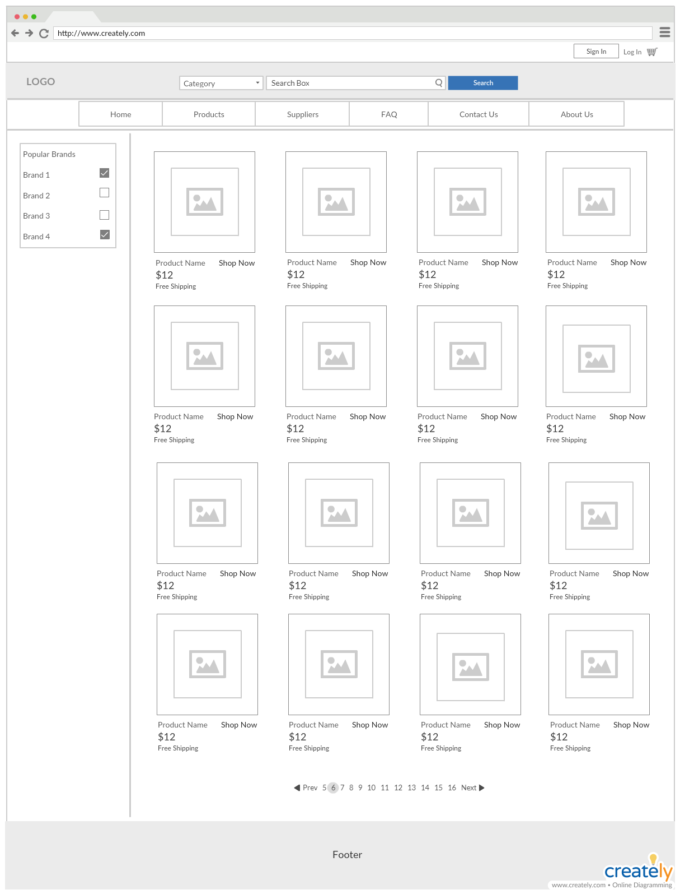

Login/Register Page

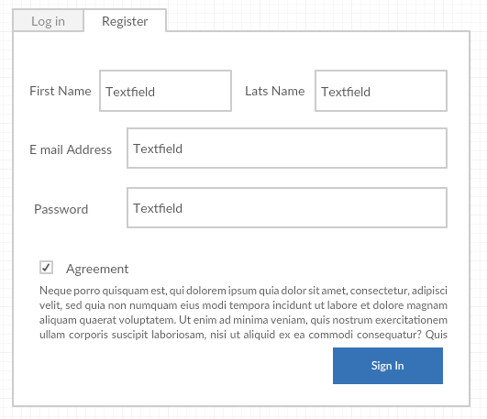

# Database Design

## Tables

* Products
* Suppliers
* Users
* Orders
* Order Details
* Categories
* Role

*Note: Need a better way to distinguish between Admin and Customers.*

## ERD

*Made on Creately*

Edit Link: <https://creately.com/diagram/jkuz415f1/HWIfPBmHA9KBtdQDCSdHBl7cRaQ%3D>

View Link: <https://creately.com/diagram/jkuz415f1/9QYLSwdXxzIrqDwuHbXRh5lQCbE%3D>

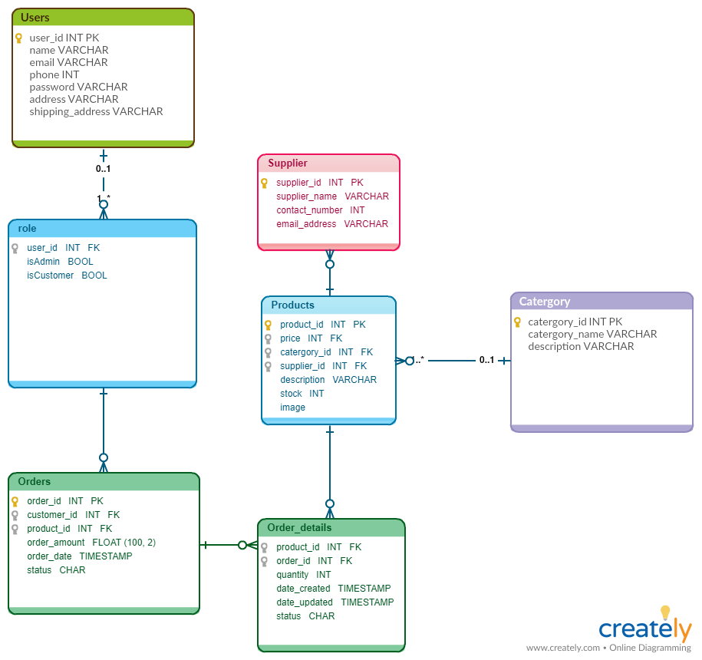

# System Design Rationale

## Techniques

### Client-side

* HTML 5 used for structuring and presenting content.
* CSS to describes how HTML elements are to be displayed.
* JavaScript to manipulate data.
* AJAX to communicate with server to request, update, receive and send data.
* Bootstrap an open-source frontend framework for designing websites/web applications. Contains HTML and CSS based design templates.
* Html helper is a class to create HTML code programmatically and used in View to display HTML Content.
* Tag helpers used in MVC to improve readability of razor code.

### Server-side

* ASP.NET Core is a cross-platform, high-performance, open-source framework for building modern, cloud-based, Internet-connected applications.
* Entity Framework (EF) is an object-relational mapper that enables .NET developers to work with relational data using domain-specific objects. It eliminates the need for most of the data-access code that developers usually need to write.
* ASP.NET MVC is a web application framework developed by Microsoft, which implements the model–view–controller (MVC) pattern
* ASP.NET Scaffolding is a code generation framework for ASP.NET Web applications.
* Razor for embedding server-based code into web pages, it’s a general-purpose templating engine that can generate output like HTML.

# Test Plan

|  |  |  |  |
| --- | --- | --- | --- |
| Requirement to Test | Test Data Input | Expected Output | Actual Output |
| Logo display on Page | Click Home, and wait for page to load | Logo is loaded and when clicked redirects to Home. | As Expected |
| Navigation Bar Testing | Click “Contact Us” | Links to Contact page | As Expected |
|  | Click “About Us” | Links to About Page | As Expected |
|  | Click “Home” | Links to Home Page | As Expected |
|  | Click “Products” | Links to Products Page | As Expected |
|  | Click “Login” | Links to Login Page | As Expected |
|  | Click “Register” | Links to Register Page | As Expected |
| Carousel Testing | Images change automatically | Images Change | As Expected |
|  | Click Left arrow | Goes to previous image | As Expected |
|  | Click Right arrow | Goes to next image | As Expected |
| Quick Link Buttons (Home Page) | Click “More Maori Gifts” | Goes to Maori Gifts category | As Expected |
|  | Click “More T-Shirts” | Goes to T-Shirts category | As Expected |
|  | Click “More Mugs” | Goes to Mugs category | As Expected |
|  | Click “More Pins” | Goes to Pins category | As Expected |
| About Page | - | About us information is shown correctly. |  |
| Contact Page | - | Contact information is shown correctly |  |
| Registration |  |  |  |
| Register with empty email address | Click on “Register” button | Error message “The Email field is required” is displayed. | As Expected |
| Register with invalid email address | Click on “Register” button | Error message “The Email field is not a valid e-mail address” is displayed. | As Expected |
| Register with existing email address | Click on “Register” button | Error message “User name is already taken” is displayed. | As Expected |
| Register with empty password | Click on “Register” button | Error message “The Password field is required” is displayed. | As Expected |
| Register with invalid password | Click on “Register” button | Error message “The Password must be at least 6 and at max 100 characters long” is displayed. | As Expected |
| Register with unmatched confirm password | Click on “Register” button | Error message “The password and confirmation password do not match” is displayed. | As Expected |
| Register with empty last name | Click on “Register” button | Error message “The Last Name field is required” is displayed. | As Expected |
| Register with invalid last name | Click on “Register” button | Error message “Please make sure your last name starts with a capital letter” is displayed. | As Expected |
| Register with empty first name | Click on “Register” button | Error message “The First Name field is required” is displayed. | As Expected |
| Register with invalid first name | Click on “Register” button | Error message “Please make sure your first name starts with a capital letter” is displayed. | As Expected |
| Register with empty mobile phone number | Click on “Register” button | Error message “The Mobile Phone Number field is required” is displayed. | As Expected |
| Register with empty address | Click on “Register” button | Error message “The Address field is required” is displayed. | As Expected |
| Register with invalid address | Click on “Register” button | Error message “The Address must be at least 6 and at max 100 characters long” is displayed. | As Expected |
| Register with empty home phone number and work phone number, and all valid other fields | Click on “Register” button | Register successfully.  Message “To login, please check your inbox (or spam) for a confirmation email” is displayed. | As Expected |
|  | Check the email inbox, and confirm the account | Account is confirmed.  Message “Thank you for confirming your email. Please Click here to Log in” is displayed. | Confirmation Email is either not sent/ or receivable. |
| Login |  |  |  |
| Log in to the system with empty email and password | Click “Log in” on the right of the navigation bar  Click “Log in” button | Display Log in page  The Log in is prevented.  Display error messages “The Email field is required.” and “The Password field is required.” | As Expected |
| Log in to the system with invalid email and password | Click “Log in” on the right of the navigation bar  Input an invalid email with password and click “Log in” button | Display Log in page  The Log in is prevented.  Display error message “Invalid login attempt.”. | As Expected |
| Log in to the system with valid administrator email and password | Click “Log in” on the right of the navigation bar  Input valid registered customer email and password and click “Log in” button | Display Log in page  Log in successfully.  Admin dropdown menu is displayed.  “Hello, Admin!” is displayed on the right navigation. | As Expected |
|  | Click on the dropdown menu | The administrator can view and manage Product, Orders, Category and Members | As Expected |
|  | Click on the welcome message | The administrator can view the account settings, profile information and order details. | As Expected |
|  | Click on the “view your orders” | All the orders for this customer will be listed. |  |
|  | Click on “Details” | Each order details will be displayed. |  |
| Log in to the system with valid customer email and password | Click “Log in” on the right of the navigation bar  Input valid registered customer email and password and click “Log in” button | Display Log in page  Log in successfully.  “Hello, (First Name)!” is displayed on the right navigation. | As Expected |
|  | Click on the welcome message | The customer can view the account settings, profile information and order details. | As Expected (except for Order which I was unable to test) |
|  | Click on the “view your orders” | All the orders for this customer will be listed. | Unable to Test |
|  | Click on “Details” | Each order details will be displayed. | Unable to Test |
| Shopping Cart |  |  |  |
| Add an item to shopping cart | Select a target bag and click “Add to cart” | The Shopping Cart has one item and the product ID, name, category, unit price, quantity, subtotal, GST and grand total price are displayed in the shopping cart. | NullReferenceException: Object reference not set to an instance of an object.  Wasn’t able to solve it, and followed the tutorial (on moodle) as best I could. |
| Add the same item to shopping cart | Select the same item and click “Add to cart” | The quantity for this product is increased to two, and the subtotal, GST and grand total is adjusted as well. | Unable to Test due to error above. |
| Reduce a product quantity(quantity>1) | Click on “x” sign after the quantity of this product in shopping cart | The quantity has decreased by 1. | Unable to Test due to error above. |
| Remove a product from shopping cart (quantity=1) | Click on “x” sign after the quantity of this product in shopping cart | The item is removed from shopping cart. | Unable to Test due to error above. |
| Clear the shopping cart | Click on “Clear Cart” | All the items are removed from the shopping cart. | Unable to Test due to error above. |
| Checkout | Click on “Checkout” | The page is directed to Log in page for further purchase. | Unable to Test due to error above. |
| Place an order | Click on “Checkout” in the shopping cart | The page is directed to Log in page for further purchase. | Unable to Test due to error above. |
|  | Log in with valid account email and password | The member information is displayed for confirmation. | Unable to Test due to error above. |
|  | Click on “Place an order” | The order is successfully created.  All the order details are displayed. | Unable to Test due to error above. |
| Category Management |  |  |  |
| View categories | Click “Admin” dropdown menu and select “Category management” | All the categories are displayed. | As Expected |
| Create a new category | Click on “Create new”.  Enter the name field with valid category.  Click on “Create” | New category is created, and the page is redirected to category management page. | As Expected |
| Edit an existing category | Select a category and click on “Edit”.  Change to a new category and click on “Save”. | Category is changed, and the page is redirected to category management page. | As Expected |
| Check category details | Select a category and click on “Details”. | The category and all the products in this category are displayed. | As Expected |
| Delete a category without any items | Select a category and click on “Delete”. | Message “Are you sure you want to delete this?” is displayed. | As Expected |
|  | Click on “Delete” to confirm. | The category is deleted. | As Expected |
| Delete a category with existing items | Select a category and click on “Delete”. | Message “Are you sure you want to delete this?” is displayed. | As Expected |
|  | Click on “Delete” to confirm. | The deletion is prevented.  Error message “The Category being deleted contains at least one item. Delete those items before trying again” is displayed. | Category and Items are both deleted. |
| Supplier Management |  |  |  |
| View suppliers | Click “Admin” dropdown menu and select “Supplier management” | All the suppliers are displayed. | As Expected |
| Create a new supplier | Click on “Create new”.  Enter the required fields with empty information.  Click on “Create” | The creation is prevented.  Error messages “The Name field is required”, “The Email Address field is required”, and “The Mobile Phone Number field is required” are displayed. | As Expected |
| Create a new supplier | Click on “Create new”.  Enter the required fields with valid information.  Click on “Create” | New supplier is created, and the page is redirected to supplier management page. | As Expected |
| Edit an existing supplier | Select a supplier and click on “Edit”.  Change the name of the supplier and click on “Save”. | Supplier is changed, and the page is redirected to supplier management page. | As Expected |
| Check supplier details | Select a supplier and click on “Details”. | The supplier information is displayed. | As Expected |
| Delete a supplier without any items | Select a supplier and click on “Delete”. | Message “Are you sure you want to delete this?” is displayed. | As Expected |
|  | Click on “Delete” to confirm. | The supplier is deleted. | As Expected |
| Delete a supplier with at least one product | Select a supplier and click on “Delete”. | Message “Are you sure you want to delete this?” is displayed. | As Expected |
|  | Click on “Delete” to confirm. | The deletion is prevented.  Error message “The Supplier being deleted contains at least one item. Delete those items before trying again” is displayed. | Supplier and Items are both deleted. |
| Product Management |  |  |  |
| View products | Click “Admin” dropdown menu and select “Product management” | All the products are displayed. | As Expected |
| Create a new product | Click on “Create new”.  Enter the required fields with empty information.  Click on “Create” | The creation is prevented.  Error messages “The Name field is required”, “The CategoryID field is required”, “The Price field is required”, “The Description field is required”, and “The SupplierID field is required” are displayed. | As Expected |
| Create a new product | Click on “Create new”.  Enter the required fields with valid information.  Click on “Create” | New product is created, and the page is redirected to product management page. |  |
| Edit an existing item | Select a product and click on “Edit”.  Change the name of the product and click on “Save”. | Product is changed, and the page is redirected to product management page. | As Expected |
| Check product details | Select a product and click on “Details”. | The product information is displayed. | As Expected |
| Delete an item without any orders | Select a product and click on “Delete”. | Message “Are you sure you want to delete this?” is displayed. | As Expected |
|  | Click on “Delete” to confirm. | The product is deleted. | As Expected |
| Delete a product with at least one order | Select a product and click on “Delete”. | Message “Are you sure you want to delete this?” is displayed. | As Expected |
|  | Click on “Delete” to confirm. | The deletion is prevented.  Error message “The product being deleted has been used in previous orders. Delete those orders before trying again.” is displayed. | Unable to test due to error (explained in Cart Testing) |
| Order Management |  |  |  |
| View orders | Click “Admin” dropdown menu and select “Order management” | All the orders are displayed. | Unable to Test, though expect it to work similarly to product or category. |
| Check order details | Select an order and click on “Details”. | The order details are displayed. | Unable to Test, though expect it to work similarly to product or category. |
| Delete an order | Select an order and click on “Delete”. | Message “Are you sure you want to delete this?” is displayed. | Unable to Test, though expect it to work similarly to product or category. |
|  | Click on “Delete” to confirm. | The order is deleted. | Unable to Test, though expect it to work similarly to product or category. |
| Account Management |  |  |  |
| View member accounts | Click “Admin” dropdown menu and select “Account management” | All member accounts are displayed. | As Expected |
| Enable a disabled account | Click on “Enable” | A tick for the enable checkbox appears. | As Expected |
| Disable a valid account | Click on “Disable” | No tick for the enable checkbox any more. | As Expected |
| Edit an account | Click on “Edit” and change the first name to another valid first name | The member account is changed, and the page is redirected to Account management page. | Unable to Edit due to a 404 error, where it doesn’t seem to able to find the user via id. |
| View an account detail | Click on “Details” | The account details are displayed. | Unable to Edit due to a 404 error, where it doesn’t seem to able to find the user via id. |
| Delete an account without orders | Select an account and click on “Delete”. | Message “Are you sure you want to delete this?” is displayed. | Unable to Edit due to a 404 error, where it doesn’t seem to able to find the user via id. |
|  | Click on “Delete” to confirm. | The account is deleted. | Unable to Edit due to a 404 error, where it doesn’t seem to able to find the user via id. |
| Delete an account with at least an order | Select an account and click on “Delete”. | Message “Are you sure you want to delete this?” is displayed. | Unable to Edit due to a 404 error, where it doesn’t seem to able to find the user via id. |